Warren Family
1903 Gwynn Oak Ave, Baltimore, MD
Grandfather Warren
Purchased property in ~1915 – operated a contracting business
**Wilson C. Warren Adelaide Warren
Wilson is individual owner of 1246 shares of common stock in and 100 shares of preferred stock in Baltimore Transit Company. He and Adelaide are joint owners of an additional 29 shares of common stock. Began acquiring stock July 1, 1935, and continued to do so for over 25 years.
Case summary: 1947-1948 – Suit Files by couple alleged that the National City Lines, which, owns a substantial share of BTC stock, is presently under indictment in a California Federal Court on charges of conspiracy to monopolize.

Evening Sun: January 16, 1957
Wilson C. Warren is a 59-year old surveyor who is running as an independent Democrat in the councilmanic election form the First district. As with many Baltimore countians, Mr. Warren was born in Baltimore City. He moved to the county in 1920 settling in the Woodlawn area. He was educated in the public schools of Baltimore city and was graduated from the Baltimore Polytechnic Institute as a member of the class of 1915. Civil Engineering Degree: The candidate attended the Tri-State College in Angola, Ind., and was awarded a bachelor of science degree in civil engineering. While at Tri State during World War I, he was a member of the Student Army Training Corps but the armistice was signed before he saw active duty with the Army.
Presently, Mr. Warren is self-employed as a land surveyor but through his life he has held many jobs. Various jobs: He worked in a drug store, sold newspapers and for many years was employed as a surveyor by the Pennsylvania Railroad. After World War II he started surveying as a free lancer. Mr. Warren says his job is his “main hobby” but that he enjoys the pastime of beekeeping and has a number of hives on his place. He is married and has one son. The Warrens live at 1903 Gwynn Oak avenue, Woodlawn.

My name is Julie Johnson and I am a graduate student at Johns Hopkins. For a class project, I am looking for any relatives or decendents of Mr. Wilson Warren who was marries to Adelaide. Our class is led by George Papenfuse, the archivist for the State of Maryland. WE were each assigned an old legal case, and were told to research all aspects and impacts of the case. Additionally, we have been asked to create a bio for one person from the case. I picked Mr. Wilson. The case begins in 1947, when he and his wife sued the National City Lines and what they were doing to the Baltimore Transit Company and its stock holders. I have found most of my information through the Baltimore Sun. I also found and article in the evening sun from 1947 when he ran for county council.
Questions: Do you know when he was born? Died?
Family history? Always in Baltimore/MD?
Do you remember anything about the lawsuit?
He was a land surveyor? Do you know anything else about his job?
Beekeeping?
His wife?
Son – Charles?
Intersting papers for the archivist?

Baltimore Polytechnic Institute (BPI), founded in 1883, known most commonly as Poly, is a magnet high school in Baltimore, Maryland. Though established as an all male trade school Poly now serves as a coeducational college preparatory institution that emphasizes mathematics, the sciences, and engineering. Poly is located on a 53-acre (210,000 m²) tract of land in North Baltimore at Falls Road and Cold Spring Lane, bordering Roland Park to the east and I-83 to the west. Poly and Western High School, originally Poly's sister school, are located on the same campus and share several amenities including a cafeteria, auditorium, and athletic fields. Baltimore City College and Poly share a long standing rivalry centered around the annual Poly–City football game. Poly is a Maryland Blue Ribbon School of Excellence.
Picture from 1911 – Principal/Director Lieutenant William King (1890-1921)
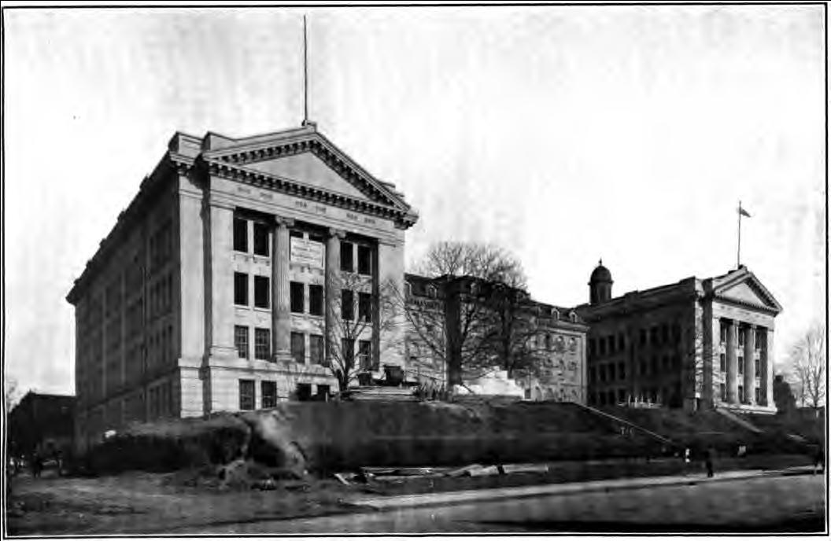

Tri-State College Angola Indiana - Trine was founded in 1884 as Tri-State Normal College. In 1906, it was renamed Tri-State College. In 1975, it was renamed to Tri-State University (TSU). Satellite campuses were opened in other Indiana locations throughout the 1990s.^{[2]} In 2008, it was renamed as Trine University to remove any reference to a state funded institution and the Tri-state area, and to honor alumnus Ralph Trine.^{[3]}

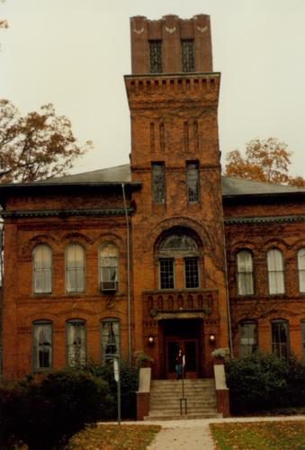

Attorney in case: HERBERT E. WITZ
215 North Charles Street
Baltimore- 1, Md.
Herbert E Witz Attorney (son??)
(410) 366-8810m 711 W 40th St Ste 357, Baltimore, MD 21211-2109
OBIT for Herbert E Witz?, Sun, November 9, 2005, p.5B, col. 1. Port.

Charles W. Warren(Deceased son of Wilson) Darlene Warren(Wife - Living)
Charles bought the house in 1978 and continued the contracted business under Maryland Diving Service, which repairs bridges, pipelines, watercraft, and other underwater facilities. After purchase, he took part in a special hearing to be allowed to continue to use this property this way (i.e. store equipment). His “elderly mother”, Adelaide, testified. When Charles dies 11/11/05, his wife, Darlene, held another special hearing to continue to use the property this way, and to take over the home. Charles did not leave a will.
Maryland Diving Service - 410-298-4471

